Donhead St Andrew Parish Council
Annual Parish Meeting - Agenda
Friday 8th March 2019 at 7pm
Donhead St Mary Village Hall
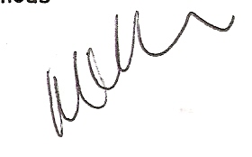
(Light refreshments will be available from 6:45pm)
The Chairman will confirm if any part of the meeting may not be filmed, photographed or audio recorded.
If any member of the public has an objection to being filmed, photographed or audio recorded, would they make themselves known to the Chairman or the Parish Clerk before the start of the meeting.
- Apologies received
- Minutes of Meeting held on 9th March 2018
- Chairman’s Annual Report for 2018/19 | P. Cnllr M. Cullimore
- Wiltshire Councillor’s Annual Report | W. Cnllr T. Deane
- Open Forum; the Parish Council wishes to hear the views of residents on the following matters:
- Nadder Community Land Trust – potential for affordable houses on land between Overway and Milkwell.
- Brookhill Traffic Management scheme
- Seating/benches at the junction of St Bartholomew’s Street and Lower Street/West End.
- Community Radio
Your chance to raise any issues: 5 minutes (maximum) will be allowed for discussion on each issue before the Chairman indicates how it will be dealt with, e.g. referred to Wiltshire Council, added to the agenda for the following meeting etc.

Note: There will be a short break at the conclusion of this meeting to allow for the March full meeting to be set up; refreshments will still be available.

All residents are very welcome to stay for the full meeting!

